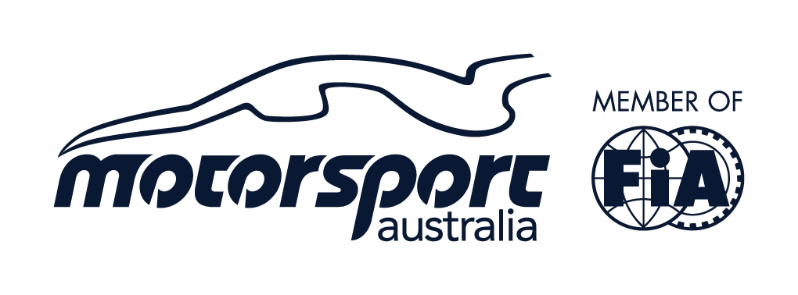

2022 STANDARD SUPPLEMENTARY REGULATIONS

CLUB MOTORKHANA

The event will be conducted under the International Sporting Code of the FIA., the National Competition Rules of Motorsport Australia., the Speed and Non-Speed Event Standing Regulations, The Motorsport Australia Motor Sport Passenger Ride Activity (MSPRA) Policy the Motorsport Australia Come and Try Policy, these Supplementary Regulations and any further Supplementary Regulations or Bulletins which may be issued. This Event will be conducted under and in accordance with Motorsport Australia OH&S, Safety 1st and Risk Management Policies. This Event will be conducted under and in accordance with any and all of the current Motorsport Australia COVID-19 Ready to Race strategy requirements, which can be found on the Motorsport Australia website at www.motorsport.org.au. Certain public, property, professional indemnity and personal accident insurance is provided by Motorsport Australia in relation to the event. Further details can be found in the Motorsport Australia Insurance Handbook, available at www.motorsport.org.au.

- ORGANISING CLUB: Road and Track Drivers Club PERMIT NO: 222/1607/01

- NAME OF EVENT: RTDC Motorkhana Round 2

- TYPE OF EVENT: Club Motorkhana

- DATE: Saturday 16th July 2022

- VENUE / LOCATION: Sydney Motorsport Park (Skidpan)

- TYPE OF SURFACE: Concrete (wet)

- TESTS: A minimum of 3 tests will run from the Motorkhana Handbook and one test
designed by RTDC in compliance with the Motorkhana rules.

- INVITED CLUBS (WHERE APPLICABLE): Any NSW affiliated car club
- CLERK OF COURSE: Johnathan Meads – ID # 1110879
(Clerk of Course will be Judge of Fact)
0408 499 404

- ASSISTANT CLERK OF COURSE:
- COMPLIANCE CHECKER: N/A
- COVID-19 CHECKER: ARDC and Johnathan Meads
- SECRETARY: Renee Meads
ADDRESS: 9 Brigalow place, Engadine
PHONE: 0450 909 785

- ENTRIES TO EVENT SECRETARY $85 non RTDC members, $70 RTDC members

- UNTIL (DATE) 6pm 15th July 2022 (no late entries accepted on the day)

- REFUNDS: 0 – 7 days –NO REFUND
7 – 14 days – 50%
14 – Over – 100%

- MAXIMUM NUMBER OF COMPETITORS: 36 plus 5 reserves

- MAXIMUM ENTRIES PER VEHICLE: 2

- STARTING TIME: 6:30 pm

- DRIVER'S BRIEFING: Will be held near the shed on the skidpan at 6.20pm

- SCRUTINEERING: All Entrants must complete the Self-Check Scrutineer report prior to the event and return by email to
events@rtdc.com.au by Friday 15th July 2022 at 6pm to comply with Motorsport Australia and
New South Wales Government COVID-19 restrictions

- SCRUTINEERING - SPECIAL RESTRICTIONS:
Approved helmets in accordance with Schedule D of the current Motorsport Australia Manual are to be worn in ALL specials. All apparel must comply with Schedule D of the current Motorsport Australia Manual. All Vehicles shall comply with Schedule A and 4H of the current Motorsport Australia Manual. Cars must be adequately muffled. Fuel must be in accordance with Schedule G of the current Motorsport Australia Manual. Current Motorsport Australia Speed/Speed Junior Licences & Motorsport Australia-Affiliated Club Membership Cards and Log Books (if issued) shall be presented at Scrutiny.

- FINES: Failure to produce MOTORSPORT AUSTRALIA Licence $55.00
Failure to produce evidence of a current Motorsport Australia affiliated Club Membership will result in the entrant having to join RTDC for a minimum of 12 months to participate in the event. Evidence of Club Membership is the Club card or a Letter from the Secretary of the Club.

- Spectators are permitted at the venue as long as the COVID rule of 1.5m between people

- CLASSES: AWD, FWD, RWD

- PRIZES AND TROPHIES: Not Applicable

- The Motorsport Australia permit will be displayed at the start of the event.

- The organisers may refuse any entry in accordance with the NCR of the current Motorsport Australia Manual. Organisers may also refuse entry for anybody that does not meet ARDC COVID-19 Health check or comply with the regulations set from RTDC, ARDC and Motorsport Australia

- Entries will be accepted in order of receipt.

- Entries from competitors under 18 years of age must be counter signed / consented to by a parent/guardian.

- Certain public, property, professional indemnity and personal accident insurance is provided by Motorsport Australia in relation to the event. Further details can be found in the Motorsport Australia Insurance Handbook, available at https://motorsport.org.au/

- The organisers may cancel, alter, abandon or postpone the event without assigning a reason in accordance with the NCR of the current Motorsport Australia Manual.

- Protests, if any, must be lodged in accordance with the NCR.

- Any The holder of a Motorsport Australia Licence (or a Licence issued by another ASN) may be tested for the presence of any drug or other banned substance and subject to a penalty for a breach of the Australian National Anti-Doping Policy and/or the Motorsport Australia Illicit Drugs in Sport (Safety Testing) Policy at www.motorsport.org.au.
Consumption of alcohol in the paddock, pits or any other Reserved Area is prohibited until all Competition is concluded each day. The holder of a Motorsport Australia Licence (or a Licence issued by another ASN) may be tested for the presence of alcohol by a Motorsport Australia Accredited Testing Official (CATO) in accordance with the Motorsport Australia Alcohol Policy at www.motorsport.org.au.

- Any special requirement by the Club should be noted here.

COMPETITORS
- Early registration is encouraged.
- Entries will not be accepted on the day.
- Entry form will require Entrants to provide a current Motorsport Australia licence number and expiry date as well as their Club Membership expiry so all information can be checked prior to the event to avoid any contact for COVID-19 compliance laws

- PASSENGERS
This Event will include a Motor Sport Passenger Ride Activity (MSPRA) which shall be run under and in accordance with the Motorsport Australia MSPRA Policy.

- DRIVER SAFETY
T-shits and shorts are permitted. No singlets or football shorts
Adequate footwear must be worn while competing. Bare feet, thongs or sandals are not permitted.
Helmets required in open top cars.
One occupying passenger permitted per vehicle with signed disclaimer.
Drivers may be required to leave the event if not adequately complying with officials’ instructions.

